# Sql-question

## Done by :- jaimin trivedi

1. What do you understand By Database

→A database is an electronically stored, systematic collection of data. It can contain any type of data, including words, numbers, images, videos, and files. You can use software called a database management system (DBMS) to store, retrieve, and edit data.

2. What is Normalization?

→ Normalization is the process of organizing the data in the database.

* Normalization is used to minimize the redundancy from a relation or set of relations. It is also used to eliminate undesirable characteristics like Insertion, Update, and Deletion Anomalies.
* Normalization divides the larger table into smaller and links them using relationships.
* The normal form is used to reduce redundancy from the database table.

3. What is Difference between DBMS and RDBMS?

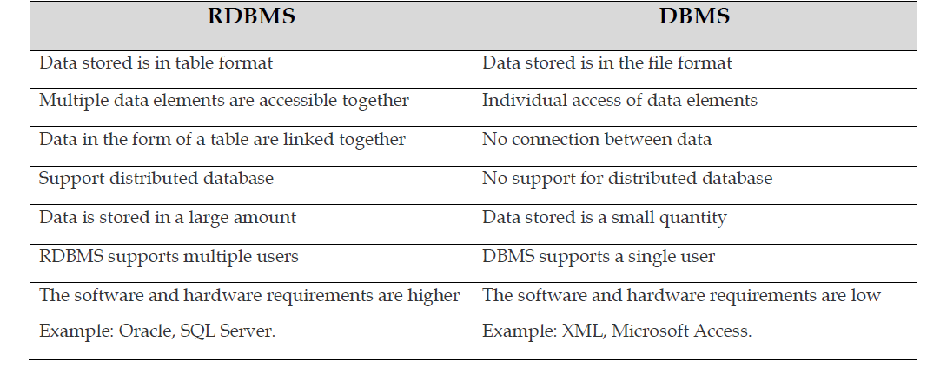

4. What is MF Cod Rule of RDBMS Systems?

I'm not familiar with an "MF Cod Rule" specifically in the context of RDBMS systems. It's possible you might be referring to one of the ACID properties of transactions in databases, which ensure data integrity.

ACID stands for:

- Atomicity: Transactions are atomic, meaning they are either completed in full or not at all.

- Consistency: Transactions bring the database from one valid state to another, maintaining integrity constraints.

- Isolation: Transactions occur independently of each other, and their effects are not visible to other transactions until they are committed.

- Durability: Once a transaction is committed, its effects are permanent and survive system failures.

If you provide more context or clarify "MF Cod Rule," I can try to offer a more specific explanation.

5. What do you understand By Data Redundancy?

Data redundancy occurs when the same piece of data exists in multiple places, whereas data inconsistency is when the same data exists in different formats in multiple tables. Unfortunately, data redundancy can cause data inconsistency, which can provide a company with unreliable and/or meaningless information.

6. What is DDL Interpreter?

Due to data redundancy, it is possible that data may not be in consistent state.

For example, consider that an address of some customer changes. And, that customer has

both kinds of accounts. Now, it is possible that this changed address is updated in only

one file, leaving address in other file as it is. As a result of this, same customer will have

two different addresses in two different files, making data inconsistent.

7. What is DML Compiler in SQL?

DML is an abbreviation of **Data Manipulation Language**.

The DML commands in Structured Query Language change the data present in the SQL database. We can easily access, store, modify, update and delete the existing records from the database using DML commands.

**Following are the four main DML commands in SQL:**

1. SELECT Command
2. INSERT Command
3. UPDATE Command
4. DELETE Command

8. What is SQL Key Constraints writing an Example of SQL Key Constraints

SQL constraints are used to specify rules for the data in a table.

Constraints are used to limit the type of data that can go into a table. This ensures the accuracy and reliability of the data in the table. If there is any violation between the constraint and the data action, the action is aborted.

Constraints can be column level or table level. Column level constraints apply to a column, and table level constraints apply to the whole table.

* [NOT NULL](https://www.w3schools.com/sql/sql_notnull.asp) - Ensures that a column cannot have a NULL value
* [UNIQUE](https://www.w3schools.com/sql/sql_unique.asp) - Ensures that all values in a column are different

9. What is save Point? How to create a save Point write a Query?

* Savepoint is a command in SQL that is used with the rollback command.
* It is a command in Transaction Control Language that is used to mark the transaction in a table.
* Consider you are making a very long table, and you want to roll back only to a certain position in a table then; this can be achieved using the savepoint.

{ mysql> **CREATE** **TABLE** student(ID **INT**, **Name** **VARCHAR**(20), Percentage **INT**, Location **VARCHAR**(20), DateOfBirth **DATE**); }

10.What is trigger and how to create a Trigger in SQL?

A trigger is a set of SQL statements that reside in system memory with unique names. It is a specialized category of stored procedure that is called automatically when a database server event occurs. Each trigger is always associated with a table.

* We cannot manually execute/invoked triggers.
* Triggers have no chance of receiving parameters.
* A transaction cannot be committed or rolled back inside a trigger.

Syntax ➖

1. **CREATE** **TABLE** Employee
2. (
3. Id **INT** **PRIMARY** **KEY**,
4. **Name** **VARCHAR**(45),
5. Salary **INT**,
6. Gender **VARCHAR**(12),
7. DepartmentId **INT**
8. )